External Documentation for Mobile Portfolio



Table of Contents

1. Description
2. Navigation
3. Colors
4. Typography
5. Wireframes

Description

My portfolio site describes my services that I can provide and shows examples of different projects I’ve worked on. I used a blue-color scheme with a black Helvetica font.

Navigation



Active navigation is shown in a different color



Hovering over a navigation button changes the color and underlines the link.

The GitHub navigation button links to an external website.

Active page is shown in a dark blue with white font.

**Mobile Navigation**

Colors

|  |  |  |
| --- | --- | --- |
| Color | Hexadecimal Value | Use(s) |
|  | #022170 | Used for hovering over navigation buttons. |
|  | #476BD6 | The bars between the header and the active navigation button color. |
|  | #2B4181 | Default navigation button color |
|  | #062170 | Keep Connected header bar and Footer bar. |
|  | #6D87D6 | Header, footer and Keep Connected background color |
|  | #FFFFFF | Content background color |
|  | #000000 | Text color |

Typography

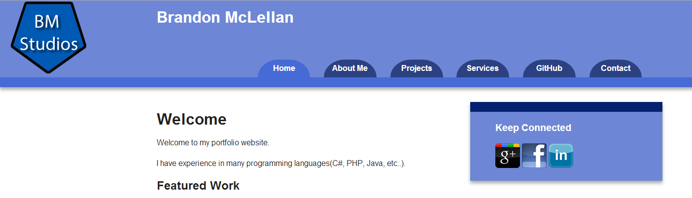

Color: White (#FFFFFF)

Font: Helvetica

Size: 1em

Color: Black (#000000)

Font: Helvetica

Size: 1em

Color: Black (#000000)

Font: Helvetica

Size: 2em

Color: White (#FFFFFF)

Font: Helvetica

Size: 1em

Color: White (#FFFFFF)

Font: Helvetica

Size: 2em

Wireframes

